**Functions:**

A **function** in **JavaScript** is similar to a procedure—a set of statements that performs a task or calculates a value, but for a procedure to qualify as a **function**, it should take some input and return an output where there is some obvious relationship between the input and the output.

function greet (name, lastName) {

console.log('Hello ' + name + ' ' + lastName);

}

greet('Joshua', 'Phillips');

greet('Winston', Churchill);

**What the code means:**

|  |  |
| --- | --- |
| **greet** | Function Name |
| **( )** | Commands within the function. |
| **Console.log** | Printing how you want the function to display. |
| **Greet (“ “, “ “)** | Function name plus data input. |

**Function Answer in console:**

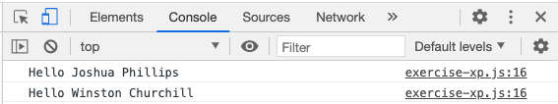

___________________________________________________________________________

**If Statements:**

The **if**/**else statement** executes a block of code **if** a specified condition is true. **If** the condition is false, another block of code can be executed. The **if**/**else statement** is a part of **JavaScript's** "**Conditional**" **Statements**, which are used to perform different actions based on different conditions.

*//Hour*

*// if hour is between 6am-12pm: Good morning!*

*// if it is between 12pm-6pm: Good afternoon!*

*// Otherwise: Good Evening!*

let hour = 10;

if (hour >= 6 && hour < 12)

console.log('Good morning');

else if (hour >= 12 && hour < 18)

console.log('Good afternoon');

else

console.log('Good evening');

**What the code means:**

|  |  |  |
| --- | --- | --- |
| **hour** | The variable | You decide a name |
| **10** | The data | (this can/will change) |
| **If ---- else if ---- else** | True or false statement | (will select an option) |
| **(hour >= 6 && hour < 12)** | The conditions for **if/ else if/ else** | (question) |
| **Console.log(‘Good Morning’);** | The printed statement | (answer) |

**Answer in console: (Because the variable (hour) is 10;)**

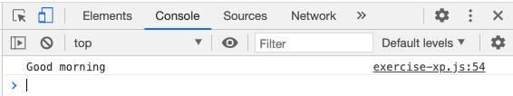

___________________________________________________________________________

**Loops:**

**For loops:**

The for **statement** creates a **loop** that is executed as long as a condition is true. The **loop** will continue to run as long as the condition is true. It will only stop when the condition becomes false. **JavaScript** supports different kinds of **loops**: ... for/in - **loops** through the properties of an object.

for (let i = 0; i < 5; i++) {

console.log('Hello World');

}

**What the code means:**

|  |  |  |
| --- | --- | --- |
| **for** | Type of loop |  |
| **i = 0; i < 5; i ++** | The variable |  |
| I = 0 | Index starts at 0 | **You must have a start** |
| **I < 5** | Index ends at 5 | **You must have an end** |
| **I ++** | Adds 1 number |  |
| **Console.log(‘Hello World’)** | Printed 5 times |  |

**Answer in the console: (Hello world is printed 5 times)**

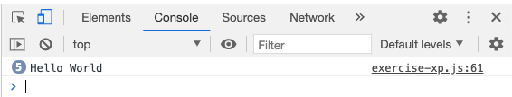

___________________________________________________________________________

**While Loops:**

The **while statement** creates a **loop** that is executed **while** a specified condition is true. The **loop** will continue to run as long as the condition is true. It will only stop **when** the condition becomes false. **JavaScript** supports different kinds of **loops**: for - **loops** through a block of code a number of times.

let i = 0;

while (i < 5) {

console.log(i);

i++

}

**What the code means:**

|  |  |  |
| --- | --- | --- |
| **i = 0** | Variable | Outside the loop (starting number) |
| **while** | The loop |  |
| **i< 5** | Index ends at 5 |  |
| **Console.log(i);** | Print i | Printing the variable |
| **I ++** | Adds 1 number | At the end |

**Answer in the console:**

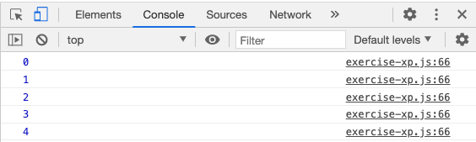

___________________________________________________________________________

**forEach Loops (Used with arrays):**

The **forEach**() method calls a function once **for each** element in an **array**, in order. Note: the function is not executed for **array** elements without values.

const animals = ['cat', 'dog', 'horse', 'sheep', 'bird'];

animals.forEach(newVariable => {

console.log(newVariable);

});

**What the code means:**

|  |  |  |
| --- | --- | --- |
| **animals** | The variable |  |
| **[“ “, “ “, “ “]** | The array |  |
| Animals.**forEach** | Variable & the loop | forEach loop |
| **(newVariable =>{** | Name of the new variable | Inside of the loop |
| **Console.log(newVariable)** | Print the new variable |  |

**Answer in console: (loops the array into once for each element)**

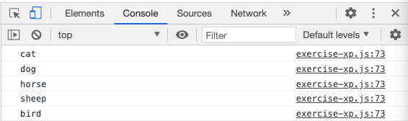

___________________________________________________________________________

**Array**

An array can hold many values under a single name, and you can access the values by referring to an index number. For example [0] or [300].

let selectedColors = ['red', 'blue', 'yellow'];

selectedColors[0] = 'new color';

console.log(selectedColors);

**What the code means:**

|  |  |
| --- | --- |
| **selectedColors** | The variable |
| **[“ “, “ “, “ “]** | The array |
| **selectedColors[0]** | Position 1 in the array |
| **selectedColors[0] = ‘new color’;** | Replacing position 1 or [0] with ‘new color’ |
| **Console.log(selectedColors);** | Print the adjustments to the array variable |

**Answer in the console: selectedColors[0] = ‘new color’; will replace red or [0].**

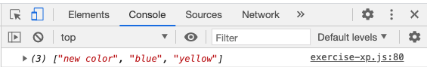

**Array methods:**

|  |  |
| --- | --- |
| **Push()** | add a new element to the end of an array |
| **Pop()** | removes the last element from an array |
| **Splice()** | add new items to an array/ remove items |
| **Slice()** | slices out a piece of an array into a new array. |
| **toString()** | converts an array to a string of (comma separated) array value. |
| **Join()** | join all the elements of an array |
| **Shift()** | To remove the first element |
| **Unshift({item})** | will add a new element to the head of the list. It will become index 0 |

___________________________________________________________________________

**Comparisons**

| **Symbol** | **Meaning** |
| --- | --- |
| = | is assignment |
| == | is comparison of value |
| === | is comparison of value and type |

| **Symbol** | **Meaning** |
| --- | --- |
| != | Not equal |
| > | Greater than |
| >= | Greater than or equal to |
| < | Less than |
| <= | Less than or equal to |
| || | Or |
| && | And |
| ! | Not (if x is true, then x! is false) |

**Working with numbers**

| **Operator** | **Example** | **Same As** |
| --- | --- | --- |
| ++ | x++ | x = x + 1 |
| -- | x-- | x = x - 1 |
| += | x += y | x = x + y |
| -= | x -= y | x = x - y |
| *= | x *= y | x = x * y |
| /= | x /= y | x = x / y |
| %= | x %= y | x = x % y |

___________________________________________________________________________